This capture shows ICMP Echo Requests being sent out, but no Echo Replies coming back. This means this device is pinging a remote host that is not responding to ICMP — which is extremely common on the modern internet.
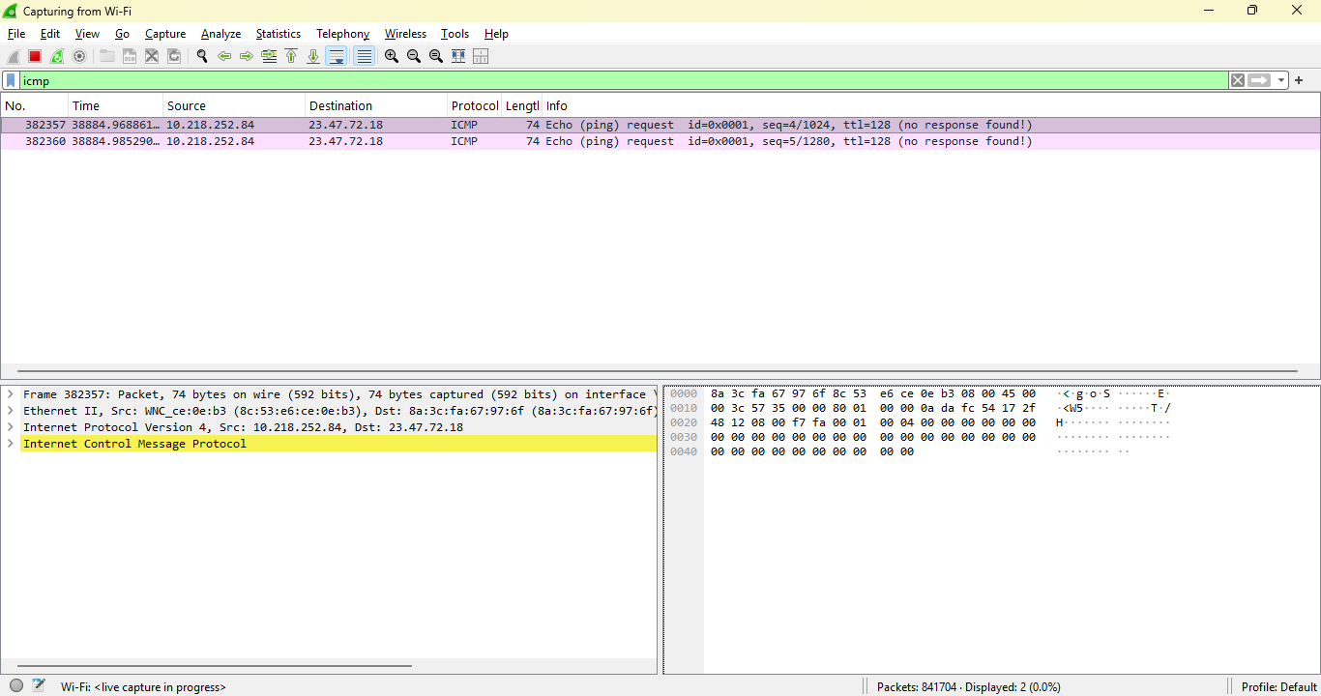
What can be learned from this capture?
This capture shows ICMP Echo Requests sent from my device (10.218.252.84) to a remote host (23.47.72.18). Wireshark indicates “no response found,” which means the destination host did not return ICMP Echo Replies. This behavior is normal for many internet-facing servers, which block ICMP for security reasons. The capture demonstrates how ICMP requests appear in Wireshark and highlights that the absence of replies does not necessarily indicate a network failure.
What this capture shows (packet-by-packet)
1. Source IP: 10.218.252.84
This is your device.
2. Destination IP: 23.47.72.18
This is the host you pinged.
3. Protocol: ICMP
Specifically:
- Echo (ping) request
- id=0x0001
- seq=4 and seq=5
- ttl=128
4. Info: “no response found!”
This is Wireshark saying:
“See’s my ping requests, but the target never replied.”
This is not an error — it’s normal behavior.
⭐ Why there is no response
Most public servers block ICMP for security reasons.
Reasons include:
- Preventing network mapping
- Preventing DDoS amplification
- Reducing attack surface
- Avoiding unnecessary load
So when pinging:
- Microsoft
- Google
- Akamai
- Cloudflare
- AWS
- Azure
- Many CDNs
… often there’s no reply.
This capture shows exactly that.
⭐ What this means in SOC / cybersecurity terms
This is actually a valuable learning moment, because SOC analysts need to understand:
✔ Not all hosts respond to ping
A lack of ICMP reply does not mean:
- The host is down
- The network is broken
- The packet was dropped
- Your system is misconfigured
It simply means:
“The host does not allow ICMP echo replies.”
✔ ICMP is often blocked at firewalls
Many enterprise networks block:
- ICMP Echo Reply
- ICMP Echo Request
- ICMP Timestamp
- ICMP Router Discovery
This is part of defense-in-depth.
✔ ICMP is still useful for diagnostics
Even without replies, we can still:
- See outbound ICMP
- Confirm routing
- Analyze TTL
- Inspect packet structure
- Verify interface selection
This is exactly what is happening.

